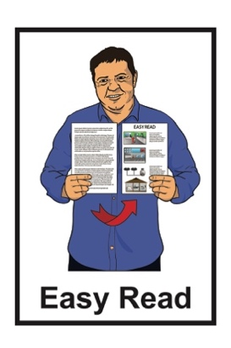


How to make the bedrooms where your children sleep safer before an earthquake
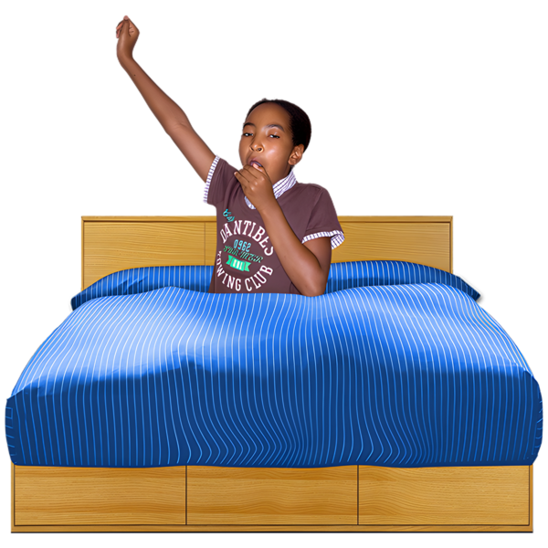

Published: August 2026

About this Easy Read


This Easy Read is from the Natural Hazards Commission Toka Tū Ake.


The Natural Hazards Commission Toka Tū Ake works to make natural hazards less harmful for New Zealanders.

They do this by:
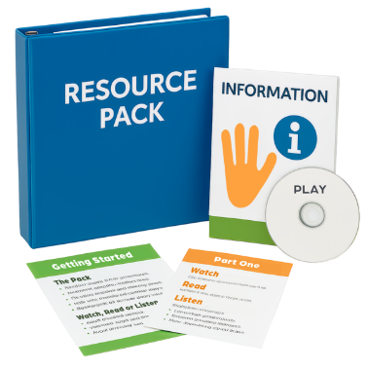
paying insurance if your home
is damaged by a natural hazard
giving New Zealanders information about how to make their homes safer from natural hazards.

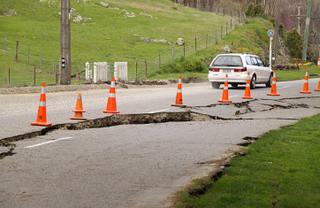
Natural hazards are natural events that could do a lot of harm like:

earthquakes
floods.

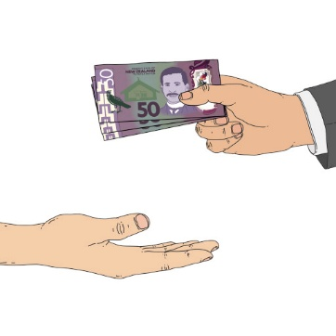
Insurance is money you get paid if something bad happens like:
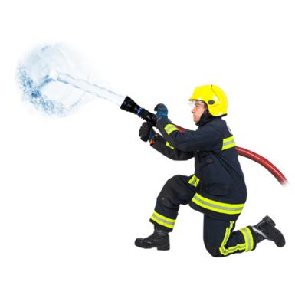
being robbed
an earthquake
your house burning down.

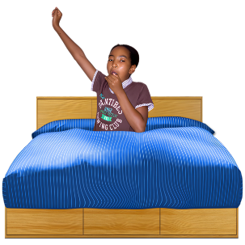
This Easy Read is about how you can make sure the bedroom is a safe place for your child in an earthquake.
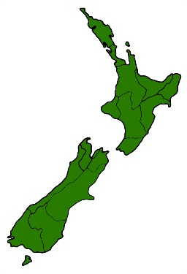

Earthquakes are a normal part of living in Aotearoa New Zealand.

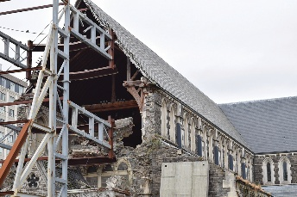

Most earthquakes:
are small
do not cause much damage.


A big earthquake could happen at any time.
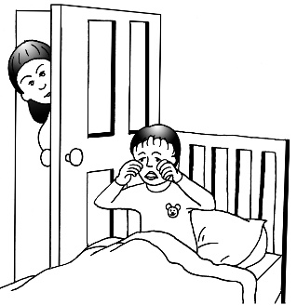

Children spend a lot of time in their bedrooms.


It is important to make sure their bedroom is a safe place to be in an earthquake.

How to make the bedroom safe before an earthquake
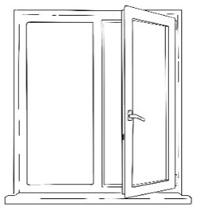

Do not put the bed / cot next to a window.
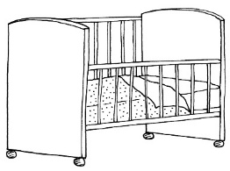

Glass could break in an earthquake.
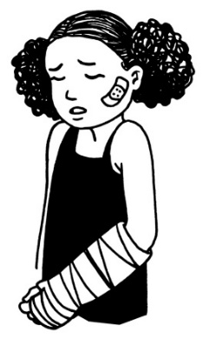

Your child could get hurt by broken glass if they are sleeping next to the window.

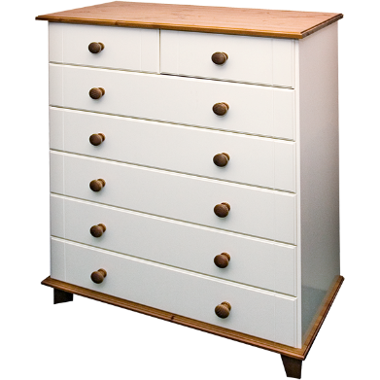
Attach tall heavy furniture to the wall like:
drawers
bookcases.

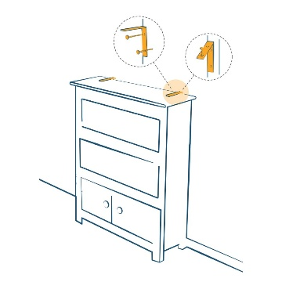
You can buy tools to attach furniture to the wall from a hardware store.

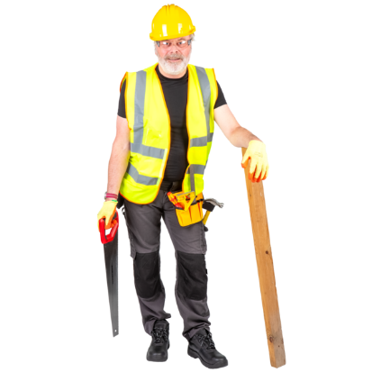
Make sure the furniture is attached to the wall stud.

The wall stud is the wooden frame inside the wall.


If you are renting your home:
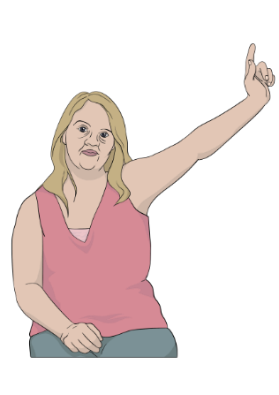
it is okay to attach furniture to the wall
you need to check with your landlord before you attach furniture to the wall.

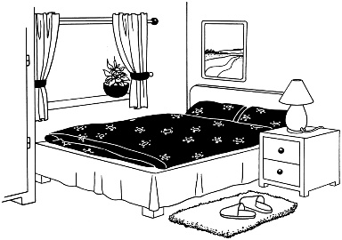
Do not put things above the bed / cot that could fall on your child like:
shelves
mirrors
heavy pictures.
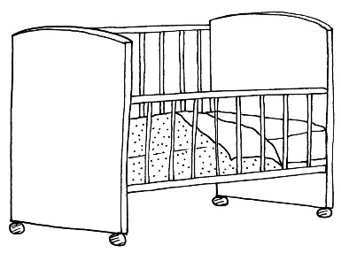

Lock the wheels if the bed / cot has wheels.

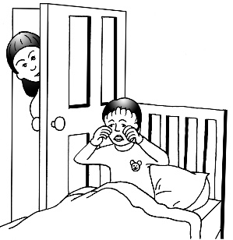
If the wheels are not locked the shaking during an earthquake could make the bed / cot move.

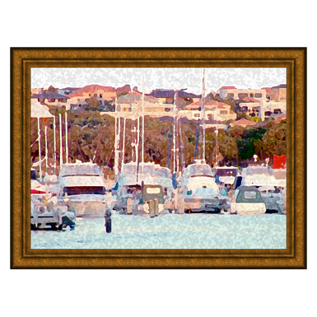
Use the right hooks to hang:
artwork
mirrors.

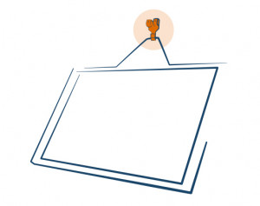
The right hooks:
are closed so things cannot fall off the hook
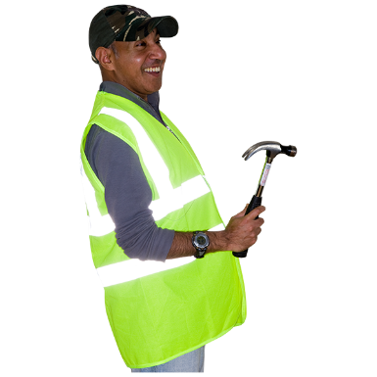
are strong enough to hold the thing you are hanging.

Do not hang artworks on single nails.

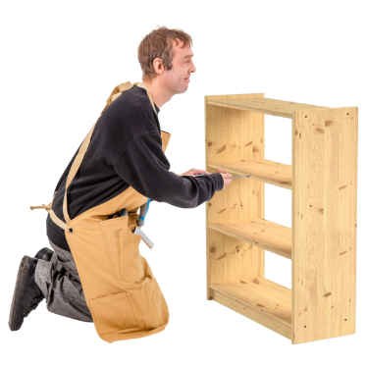
Keep heavy items on low shelves.

This means heavy items cannot fall during an earthquake.

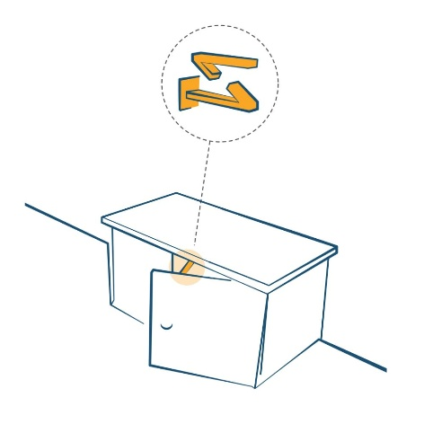
If you can use latches to keep:
cupboards closed
drawers closed.

What to do during an earthquake
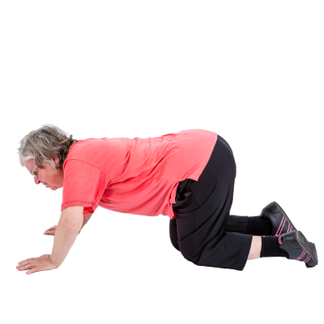

If you feel an earthquake:
drop to the ground if you can
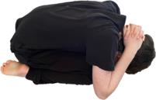
- cover your:
- head
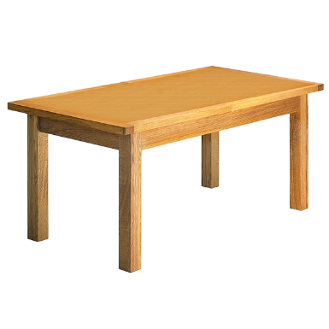
- neck
- get under strong furniture like a table if you can
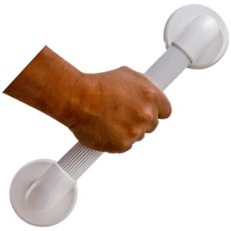
- hold on to the furniture you are under until the shaking stops.

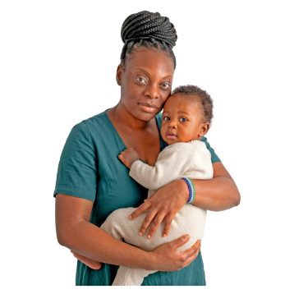
If you have a baby / young child with you:
hold them close to you
protect your own:
- head
- neck.

More information


This website has more information about how to keep young children safe in an earthquake:

https://tinyurl.com/2f86fxda

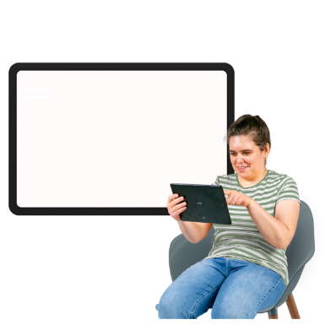
This website has more information about how to get your home ready for an earthquake:

https://tinyurl.com/4de7makm
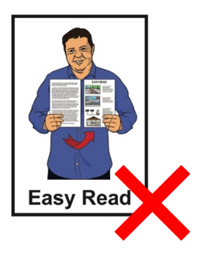

These websites are not in Easy Read.

This information has been written by the Natural Hazards Commission Toka Tū Ake.


It has been translated into Easy Read by the Make it Easy Kia Māmā Mai service of People First New Zealand Ngā Tāngata Tuatahi.

The ideas in this document are not the ideas of People First New Zealand Ngā Tāngata Tuatahi.

All images used in this Easy Read document are subject to copyright rules and cannot be used without permission.


Make it Easy uses images from:


- Photosymbols

- Change Images


- Huriana Kopeke-Te Aho

- SGC Image Works

- T Wood


- Studio Rebeko

- Inga Kramer.

